**ICN HW1**

**B09901066 謝承修**

**P1**

1. Power: input format is “a ^ b”, and the output is a^b.
2. Gcd: input format is “gcd a b”, and the output is gcd(a, b).
3. Lcm: input format is “gcd a b”, and the output is lcm(a, b).
4. Dot: input format is “v1 dot v2”, where v1 and v2 are vectors, represented by x0,y0,z0,…, and output is v1 dot v2. Eg. 2,3 dot 1,4 🡪 14
5. Dist: input format is “dist p q”, where p and q are of format (x0, y0), and output is the distance between two points. Eg. dist 4,3 1,7 🡪 5.0

**P2**

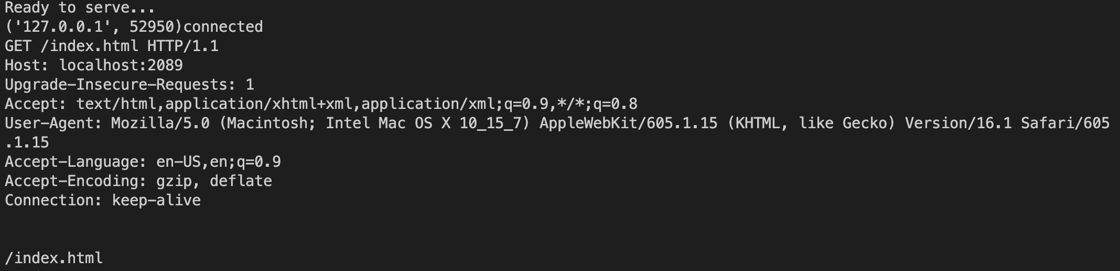

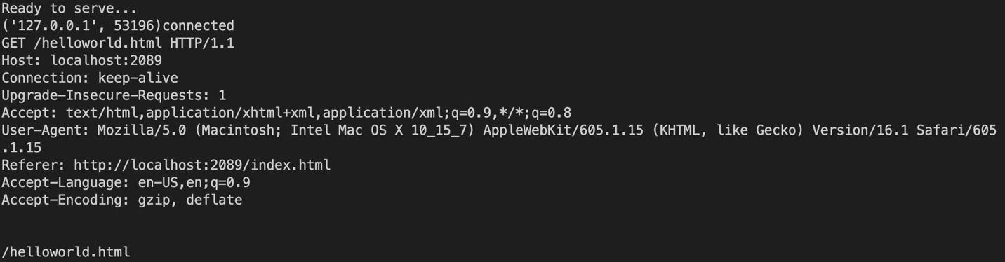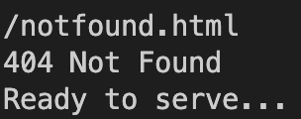

**TODO description**

Client和server先建立連結

# TODO start

HOST, PORT = "127.0.0.1", 2089

# HOST, PORT = ServerSocket.getsockname()[0], 2089

serverSocket = socket(AF_INET, SOCK_STREAM)

serverSocket.bind((HOST, PORT))

serverSocket.listen(1)

# TODO end

Server接受客戶端的訊息

# TODO start

RecvMessage = ConnectionSocket.recv(2048).decode()

print(RecvMessage)

# TODO end

用f.readlines()讀檔

# TODO start

DataInFile = f.readlines()

f.close()

# TODO end

ConnectionSocket傳header line, status, type

# Send one HTTP header line into socket

# Send HTTP Status to the client

# TODO start

ConnectionSocket.send(b'HTTP/1.1 200 OK\r\n')

# TODO end

# Send the Content Type to the client

# TODO start

ConnectionSocket.send(b'Content-Type: text/html; charset=utf-8\r\n\r\n')

# TODO end

如果檔案不存在則有錯誤處理：ConnectionSocket傳錯誤訊息

# TODO start

res = "404 Not Found"

ConnectionSocket.send((res+"\r\n").encode())

# ConnectionSocket.send(b"\r\n")

print(res)

# TODO end

關掉ConnectionSocket

# TODO start

ConnectionSocket.close()

# TODO end

**P3**

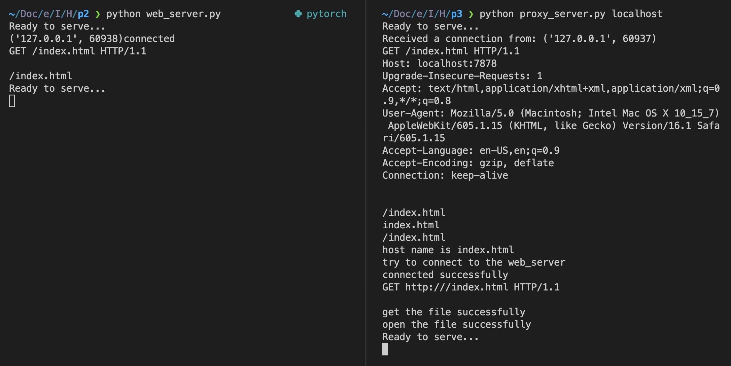

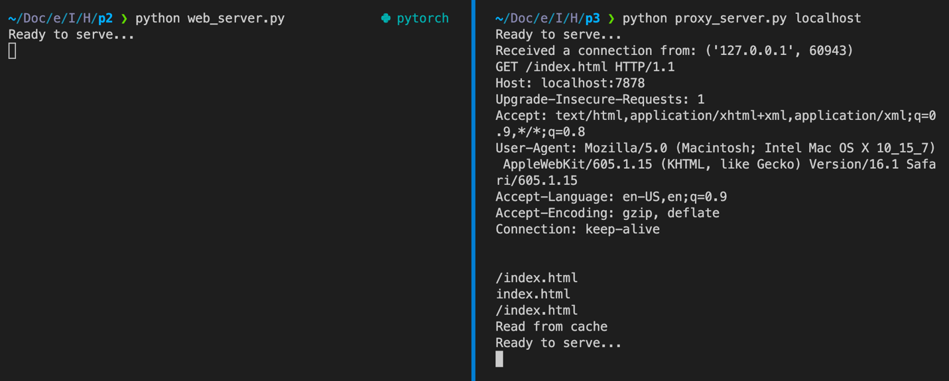

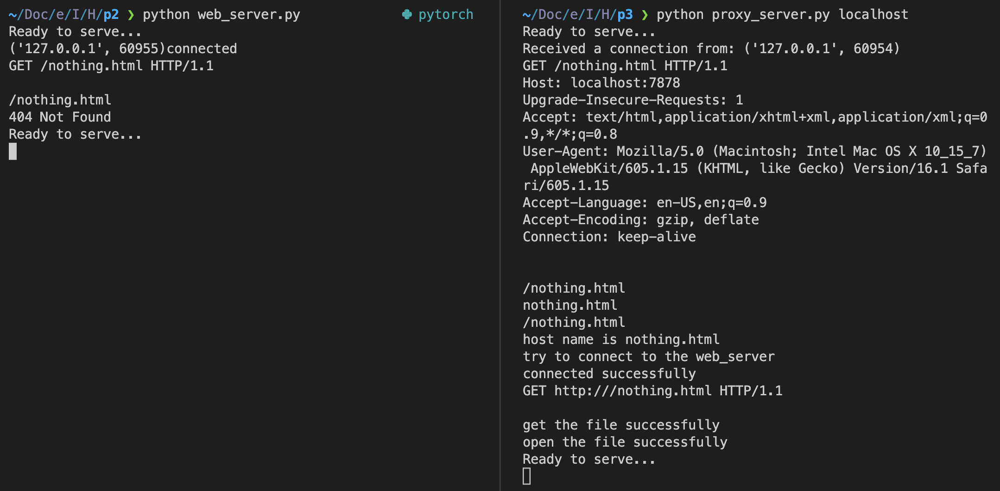

**TODO description**

前置作業（建立連接等）

# TODO start

HOST, PORT, WEB_PORT = sys.argv[1], 7878, 2089

TCPServerSocket.bind((HOST, PORT))

TCPServerSocket.listen()

# TODO end

接收訊息

# TODO start

TCPClientSocket, Addr = TCPServerSocket.accept()

# TODO end

# TODO start

RecvMessage = TCPClientSocket.recv(1024).decode()

# TODO end

Proxy -> Client (read from cache)

# TODO start

for i in range(0, len(DataInFile)):

TCPClientSocket.send(DataInFile[i].encode('utf-8'))

TCPClientSocket.send(("\r\n").encode('utf-8'))

# TODO end

建立與server連接

# TODO start

SocketOnProxyServer = socket(AF_INET, SOCK_STREAM)

# TODO end

# TODO start

SocketOnProxyServer.connect(('127.0.0.1', WEB_PORT))

# TODO end

將data讀進buffer

# TODO start

data = ''

for i in range(10):

data += SocketOnProxyServer.recv(1024).decode('utf-8')

data = data.strip()

data = data.split('<!DOCTYPE html>')[-1]

data = '<!DOCTYPE html>' + data

# TODO end

建立cache, proxy -> client

# TODO start

TmpFile.write(data)

TmpFile.flush()

TmpFile.close()

SocketOnProxyServer.close()

TCPClientSocket.send(("HTTP/1.0 200 OK\r\n").encode('utf-8'))

TCPClientSocket.send(("Content-Type:text/html\r\n").encode('utf-8'))

TCPClientSocket.send(("\r\n").encode('utf-8'))

TCPClientSocket.send(data.encode('utf-8'))

TCPClientSocket.send(("\r\n").encode('utf-8'))

# TODO end

# TODO start

TCPClientSocket.send(("HTTP/1.0 404 Error\r\n").encode('utf-8'))

TCPClientSocket.send(("Content-Type:text/html\r\n").encode('utf-8'))

TCPClientSocket.send(("\r\n").encode('utf-8'))

# TODO end

關閉server socket

# TODO start

TCPServerSocket.close()

# TODO end